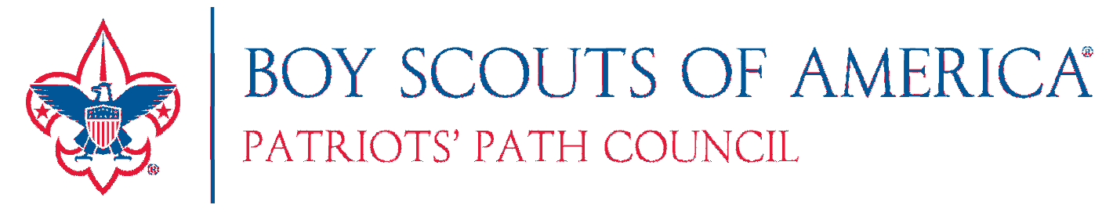

Unit Social Media Award
Recognizing Your Online Success!

Patriots’ Path Council wants to recognize units that have successfully communicated their great work on social media. If news about your unit has been published on the Patriots’ Path Facebook page at least 5 times during any consecutive 12-month period…you will be awarded a handsome flag ribbon and printed certificate.

To Apply: Complete this form and return the council service center. Attach article, photos, and/or website link

 | Title of Post | Date Posted
1
2
3
4
5

Name: __

Unit Type/Unit #: District: __

Address: Town: __

Phone: E-mail: __

Send completed form & articles to: Patriots’ Path Council
Mark Spaldo
1 Saddle Road
Cedar Knolls, NJ 07927
You can also fax or e-mail form and articles to: Fax-973-267-3406
mark.spaldo@scouting.org
Questions about the program can be directed to:
Mark Spaldo
Mark.spaldo@scouting.org
973-765-9322 ext. 251

(over)

Unit Social Media Award Program Details

- Any Cub Scout pack, Boy Scout troop, Venturing crew, Explorer post, Sea Scout ship or other traditional Scout unit may apply for the award.

- You must get your content published at least 5 times during any consecutive 12-month period on the Patriots’ Path Council Facebook page (https://www.facebook.com/ppcbsa/) to be eligible. Units will receive a printed certificate and award ribbon.

- There is no limit to the number of Social Media Awards a unit can receive.

- To be eligible for publication on the Patriots’ Path Council Facebook page, any content submitted by a unit must have genuine news value, and be of likely interest to other units. Content will be evaluated and accepted by the Marketing Committee – on the basis of its editorial and presentation quality – according to the same standards use by traditional newspapers and media outlets.

- The Marketing Committee has sole discretion over the acceptance of content submitted by units for publication on the Council Facebook page, in connection with this award. If submitted content is deemed unacceptable, the Committee will provide units with guidance on how it can be improved, so that it might qualify for publication.

- Articles and photo captions should include a description of the event, with unit and number. You can use the first name and last initial of participants. Full names are prohibited for privacy reasons. Please remember to protect our Scouts’ identity and follow Youth Protection guidelines. Alternatively, a phrase identifying the group is acceptable, ex: “Scouts from Florham Park enjoy the air show.”

- Remember to have all appropriate approval forms signed, that allow the Scouts’ pictures to be published. The talent release agreement can be found on Part B of Annual BSA Health and Medical Form. http://www.scouting.org/filestore/HealthSafety/pdf/parts_ab.pdf.

- Having Scouts in uniform is preferred, but may not always be practical. Do your best to have those in photos represent the ideals of Scouting by their clothing they wear and appropriate content.
Questions about the program can be directed to: Mark Spaldo
Mark.spaldo@scouting.org
973-765-9322 ext. 251

