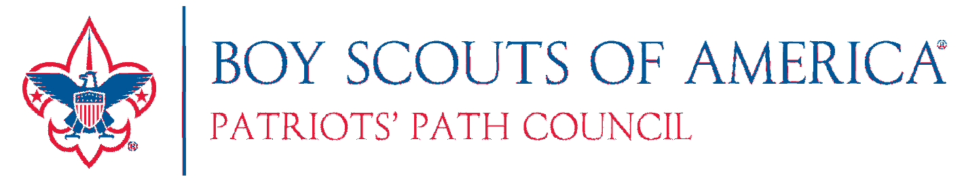

Unit Publicity Award
Recognizing Your Success!

Patriots’ Path Council wants to recognize units that have successfully publicized their great work. If news about your unit has been published in a traditional or online news publication at least 3 times during any consecutive 12-month period…you will be awarded a handsome flag ribbon and printed certificate.

To Apply: Complete this form and return the council service center. Attach article, photos, and/or website link

 | Name of Publication or Website | Date Published or Posted
1
2
3

Name: __

Unit Type/Unit #: District: __

Address: Town: __

Phone: E-mail: __

You can also fax or e-mail form and articles to: Fax-973-267-3406
mark.spaldo@scouting.org
Send completed form & articles to: Patriots’ Path Council
Mark Spaldo
1 Saddle Road
Cedar Knolls, NJ 07927
Questions about the program can be directed to:
Mark Spaldo
mark.spaldo@scouting.org
973-765-9322 ext. 251

(over)

Unit Publicity Award Program Details

- Any Cub Scout pack, Boy Scout troop, Venturing crew, Explorer post, Sea Scout ship or other traditional Scout unit may apply for the award.

- You must get published at least 3 times during any consecutive 12-month period in the general press or online news service to be eligible. Units will receive a printed certificate and award ribbon.

- There is no limit to the number of Publicity Awards a unit can receive.

- Articles must be published in a form distributed for reading by the general public outside of the Scouting community. Examples include newspapers, magazines, trade brochures, church bulletins, newsletters, online news service, etc.

- Articles and photo captions should include a description of the event, with unit and number. If allowed by the publication, use the first name and last initial of participants. Full names are prohibited for privacy reasons. Please remember to protect our Scouts’ identity and follow Youth Protection guidelines. Alternatively, a phrase identifying the group is acceptable, ex: “Scouts from Florham Park enjoy the air show.”

- Remember to have all appropriate approval forms signed, that allow the Scouts’ pictures to be published. The talent release agreement can be found on Part B of Annual BSA Health and Medical Form. http://www.scouting.org/filestore/HealthSafety/pdf/parts_ab.pdf.

- Having Scouts in uniform is preferred, but may not always be practical. Do your best to have those in the picture represent the ideals of Scouting by their clothing they wear and appropriate content.
Questions about the program can be directed to: Mark Spaldo
mark.spaldo@scouting.org
973-765-9322 ext. 251

