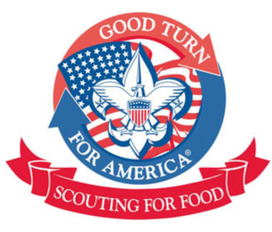
Scouting for Food is the Boy Scouts of America's nationwide service project to help stop hunger in our communities. It began as a Scout's service project in St. Louis, Missouri, in 1985, and was adopted by the Boy Scout National Organization in 1988. Primarily our Council has held food drives in Late Oct/Early November but you are welcome to host a Scouting for Food Drive at any point during the year. This is an impactful service project that helps our communities.
How to Run a drive:
District Community Service Chairpersons

Black River
Tony Cretella
apcretella@comcast.net

Fishawack
Maggie Atkins
maggieatk@aol.com

Munsee
Christy Barone
thebarones@verizon.net

Raritan Valley
Linda Cummings
lmjacummings@gmail.com

Sussex
Darlene Kishpaugh
darlenescouter@gmail.com

Watchung Mountain
Tony Campasano
acampasano@comcast.net

-Notify your district chairperson that you will be running a SFF drive.
- Contact your food bank ( some food banks are not accepting donations during this Pandemic).
-Pick up Scouting for Food Bags at either the Mountainside or Cedar Knoll Scout Shop-limit of 500 bags per unit.
-Pick Dates for delivering the Bags and picking up the bags
-Make flyers or door knob hangers to distribute with the bags.
-Distribute bags along with flyers/hangers.
-Pick up bags of donations.
-Count the number of items (not bags)collected, you will need to report this number.
-Drop off bags at the Food Bank
-Report your community service hours on Scoutbook.
- Send any pictures of your SFF drive to Linda Cummings at lmjacummings@gmail.com
Things to Remember:
Please follow state COVID-19 Guidelines regarding masks and social distancing.
Decide on whether Scouts will go out with parents or with Dens, Patrols etc. Always follow the Safe Scout guidelines.
Door hangers may not be hung on mailboxes.
Scouts should wear their Class A uniforms during all phases of the project.

Insert your information here

Insert your information here

