Resource Sheet: March 2021 Roundtable

Scout Law Point for April: Loyal Pack Meeting Theme: Cubs in the Future

April Roundtable: 1st Tuesday, 4/6/21 – via Zoom at 7:30
Scout Law Point for May: Friendly Pack Meeting Theme: “Treasure Hunters”
Theme Discussion:  The Point of the Scout Law being highlighted for Cub Scouts in April is: Point #2: A Scout is Loyal. Scouts are true to their family, friends, Scout Leaders, school, and nation.  HOW DOES “CUBS IN THE FUTURE” RELATE TO THIS POINT OF THE SCOUT LAW? What do Cub Scouts want to do when they grow up? Could they become Cub Scout leaders? In our futuristic Pack Meeting, Cub Scouts learn about the importance of being loyal to the things that are important to them, such as Scouting. What will Packs of the future look like when today’s Cub Scouts serve as leaders? What kinds of games, skits, and songs will they do at a Pack Meeting in the year 2051? Let their imaginations be the limit!  Roundtable for Special Needs Scouting:  Council-wide Zoom on Monday, March 8 at 7:30. Send your request for the Zoom link to Mary Lynne Capen at Moonmommy7@aol.com  Applause: Blast-off Cheer  Divide the audience into three groups. Have everyone put their hands together over their heads to simulate a rocket. When the leader points to it, the first group yells, “THREE,” the second group yells “TWO!” the third group yells “ONE!” Then, together they yell “BLAST-OFF!”and jump into the air. Modify for virtual use: Have everyone put their hands together over their heads. The leader yells “3-2-1” then everyone yells “BLAST-OFF!” and jumps into the air.  Closing Ceremony: The Future  Prop: Picture or model of a futuristic spacecraft.  Cub Scout #1: [Holds up spacecraft.] This cool spacecraft is someone’s vision of what the future will look like. But that’s just one person’s vision.  Cub Scout #2: We really don’t know what the future will actually be like, but we DO know that we need good people to make it as bright as possible.  Cub Scout #3: We can be sure we’re doing our best for the future by remembering to follow the Scout Oath and Law.  Cub Scout #4: Let’s think about what the Scout Oath and Law mean for the future as we say them together. Please stand.  Cub Scout #5: Cub Scout Sign: [All make Cub Scout Sign]  On my honor I will do my best  To do my duty to God and my country  and to obey the Scout Law;  To help other people at all times;  To keep myself physically strong,  mentally awake, and morally straight.  A Scout is: Trustworthy, Loyal, Helpful,  Friendly, Courteous, Kind,  Obedient, Cheerful, Thrifty,  Brave, Clean, and Reverent.  Ready….two. [All bring down sign.]  Activity: Egg Carton Spaceship Craft and Games  Start by cutting out the cups of an egg carton.  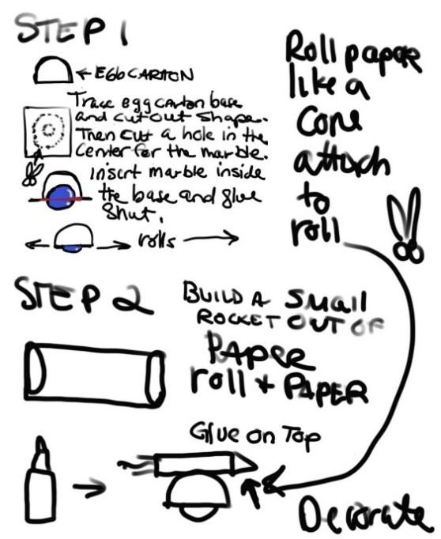  Launch your spaceship along the ground in one of these games:  - See who can roll their spaceship to “land” closest to a target  - See who can roll their spaceship the farthest in one push  - See who can get to a finish line the quickest with multiple pushes.  Game: Future Flight  IMPORTANT: DON’T USE THIS GAME IF ANYONE IN THE PACK HAS A LATEX ALLERGY!!!  Each Den gets a set of balloons of a specific color. Each person puts his/her initials on his/her balloon and all stand on the starting line and inflate the balloons, but do not tie them shut. (Parents can help blow up the balloons if needed.) On the count of “3-2-1 BLASTOFF” all release their balloons in the direction of the target line. Score 15 for each balloon over the line. 10 for all within 5 feet of the line. 5 for any between 5 and 15 feet of the line. Add up the Den scores and see who wins. Repeat if you want. [Tip: Have extra balloons in case of breakage!]  Craft and Game: Space Shuttle  Each Cub Scout makes a “space shuttle” (a “regular” paper airplane) and decorates it if there is time…at least put initials on it. All in the Den/Pack try to “dock” their shuttles by landing them in a cardboard box or laundry basket from a throwing line at a specified distance. Tally the scores after 1, 2, 3 throws.  Game: Time Capsule  Explain: A time capsule is a special container people create with items from their time. The capsule is set to be opened sometime in the future – maybe 5, 10, 25, 50, 100 years from now - to show future people things we have right now. What would you put into a time capsule for future people to see?  The Game: Cub Scouts stand or sit in a circle. The first Scout says: “We’re making a time capsule and I’m going to put in _________.” The second Scout says: We’re making a time capsule and I’m going to put in (name what Scout #1 said, then add another item.) The game continues until everyone has a turn, with each Scout naming the items from the Scouts before, then adding another one. If a Scout forgets a previous item he is out…or others can help him/her with the item. [Set up your rule about help before the game starts.] |  | Opening Ceremony: Past, Present, Future  Props: Cardboard “Time Machine” – large box or piece of cardboard with “Time Machine” written on top, and dial with numbers from 1775 to 2025, and arrow that can swivel through the numbers. Pictures for Cub Scouts with year on back of page, so they can tell when it’s their turn to hold up the picture.  Ceremony set up: Cubmaster and Assistant Cubmaster are in the front center with “Time Machine.” 8 Cub Scouts are in line, with #1 on the audience’s left. Each has his/her designated picture, with the Cub Scout # and the year on the back so they will know when to hold it up.  Ceremony: Cubmaster (CM) speaks the year, then pauses briefly while Assistant Cubmaster (ACM) moves the arrow on the “time machine” and the designated Cub Scout holds his/her picture up high. Cub Scout holds up the picture while the Cubmaster reads about the importance of the year, then puts it down when the next year is called out by the Cubmaster.  CM: Tonight, we’re travelling through time and into the FUTURE for a quick BSA history lesson, using our Time Machine! 1910…[ACM turns arrow to 1910; Cub #1 shows picture symbolic of the early years of Scouting.] This is the year the Boy Scouts of America started!  CM: 1930…[ACM turns arrow to 1930; Cub #2 shows pic of Cub Scout] This is the year Cub Scouting began in the United States.  CM: 1982…[ACM turns arrow to 1982; Cub #3 shows pic of Tiger.] This is the year that Tigers began for first graders.  CM: 2018…[ACM turns arrow to 2018; Cub #4 holds up pic of Lion & female Cub Scout] Thirty-six years later, Kindergartners officially started in Cub Scouts as Lions, and girls were invited into Cub Scouts!  CM: 2019…[ACM turns arrow; Cub Scout #5 holds up pic of female Scout] Girls were welcomed to join Scouts BSA, making all BSA programs available to all American youth.  CM: 2021… [ACM turns arrow to 2021; Cub #6 holds up pic of Cub Scout rank symbols] THIS YEAR many of our Lions, Tigers, Wolves, Bears, and Webelos will advance in rank, and our Arrow of Light Scouts will join Scouts BSA Troops!  CM: 2025… [ACM turns arrow to 2025; Cub #7 holds up pic of Scout symbol] Four years from now, believe it or not, our current Tigers will enter Scouts BSA, and our current Lions will become the oldest Cubs in our Pack. By then, some of this year’s Arrow of Light Scouts may already be EAGLE SCOUTS! WOW!  CM: 1775…[ACM turns arrow to 1775; Cub #8 holds up pic of Continental Soldier] Now, we need to make a quick detour all the way back to the year the American Revolution started! Without America’s past we wouldn’t have the present as we know it, and the future would be very different! [Cub Scout #8 brings down picture] Everyone please stand. Color Guard advance. Cub Scout salute.  [Cub Scouts 9&10 advance the American Flag and Pack Flag – American Flag comes in first and stays to its own right when facing the audience.]  CM: I pledge allegiance….with liberty and justice for all. Two. [All put down salute] Let us remember all those who have fought for our freedom these past 236 years, so our future can be secure. Please be seated.  Prayer: The Future  Dear Lord, As we look into the future, we understand that things will change. Even so, please help us to always remain true to the values of the Scout Oath and Law that guide our lives. Amen.  Activity: Lego Cub Scout Future Campsite  Well in advance of the Pack Meeting, tell the Cub Scouts that each of them gets to build their idea of a Cub Scout Future Campsite from Legos to show at the Pack Meeting. If the Pack Meeting is in person, the Cub Scouts can set up their creations on tables, with their names attached, for everyone to admire. (Ask everyone NOT to touch the displays.) If the meeting is virtual, have each Cub Scout show off his/her creation individually by using “Share Screen” so everyone can see it.  Run-ons:  Cub Scout pairs, for each run-on, run up to the microphone and say their lines slowly and clearly, then leave. Cub Scout #1 asks the question; #2 gives the answer, or you can use a more extended version as shown below in A.. After each run-on, a third Cub Scout can wave a sign that says “GROAN” for the audience to see. (The “GROAN” sign is good for Cubs who don’t feel comfortable speaking.)  Run-on A: Cub #1: Why did the sun go to school?  Cub #2: I don’t know. Why DID the sun go to school?  Cub #1: To get brighter!  Run-on B:  Q: How do you know when the moon has enough to eat?  A: When it’s full.  Run-on C:  Q: What kind of music do planets sing?  A: Neptunes!  Run-on D:  Q: What’s a light-year?  A: The same as a regular year, but with fewer calories.  Run-on E:  Q: Why did the cow go up in the spaceship?  A: It wanted to visit the mooooooon!  Run-on F:  Q: Why did the cow go to outer space?  A: To see the milky way.  Run-on G:  Q: How does the man in the moon cut his hair?  A: Eclipse (he clips) it!  Run-on H:  Q: How do you organize an outer space party?  A: You planet (plan it)!  Run-on I:  Q: How does the solar system hold up its pants?  A: With an asteroid belt!  Demonstrations or Other Activities:  If there is a Den that needs to do some type of activity at your Pack Meeting for the completion of an Adventure this month, make sure to plan for it!  FOR APRIL ROUNDTABLE:  Bring something treasure-related and add to the FUN!  For even more FUN – BRING A FRIEND!

